Assignment #7: Wave phenomena

- An ocean wave has a period of 10 seconds. It has a wavelength of 5 meters.
  - What is the frequency of the wave.

  - A surfer is riding the wave. How long will it take him to go 100 meters?

- The speed of a wave in a slinkey is 5 m/s. What is the frequency that the slinkey should be driven at to cause a standing wave to form with three antinodes (assume one end of the slinkey is glued to the wall.)

- Middle C has a frequency of 512 Hz. What is the wavelength of the wave at Sea Level?

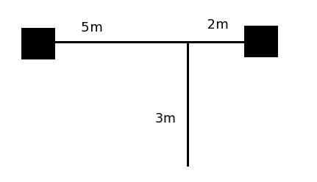

- Two speakers are separated by 7 m. The first “dead spot” is heard 3 meters in front of the speakers, and 2 meters from the right speaker. What is the frequency that the speakers are driven at? (Assume v_{s} = 343 m/s)

O C T A V E N U M B E R
 | 0 | 1 | 2 | 3 | 4 | 5 | 6 | 7 | 8
C | 16.35 | 32.70 | 65.41 | 130.81 | 261.63 | 523.25 | 1046.50 | 2093.00 | 4186.01
C# | 17.32 | 34.65 | 69.30 | 138.59 | 277.18 | 554.37 | 1108.73 | 2217.46 | 4434.92
D | 18.35 | 36.71 | 73.42 | 146.83 | 293.66 | 587.33 | 1174.66 | 2349.32 | 4698.64
D# | 19.45 | 38.89 | 77.78 | 155.56 | 311.13 | 622.25 | 1244.51 | 2489.02 | 4978.03
E | 20.60 | 41.20 | 82.41 | 164.81 | 329.63 | 659.26 | 1318.51 | 2637.02 | 5274.04
F | 21.83 | 43.65 | 87.31 | 174.61 | 349.23 | 698.46 | 1396.91 | 2793.83 | 5587.65
F# | 23.12 | 46.25 | 92.50 | 185.00 | 369.99 | 739.99 | 1479.98 | 2959.96 | 5919.91
G | 24.50 | 49.00 | 98.00 | 196.00 | 392.00 | 783.99 | 1567.98 | 3135.96 | 6271.93
G# | 25.96 | 51.91 | 103.83 | 207.65 | 415.30 | 830.61 | 1661.22 | 3322.44 | 6644.88
A | 27.50 | 55.00 | 110.00 | 220.00 | 440.00 | 880.00 | 1760.00 | 3520.00 | 7040.00
A# | 29.14 | 58.27 | 116.54 | 233.08 | 466.16 | 932.33 | 1864.66 | 3729.31 | 7458.62
B | 30.87 | 61.74 | 123.47 | 246.94 | 493.88 | 987.77 | 1975.53 | 3951.07 | 7902.13

- A trombone has a length of 2.743 m, and produces an A#2 at its first fundamental resonance.
  - What is the speed of sound in brass? (Wind instruments are open-tubes)

  - What is the wavelength of the second harmonic?

  - What note is the second harmonic closest to?

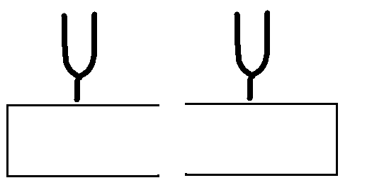

- Two tuning forks are placed on empty wooden boxes. Both tuning forks are pitched at middle-C (C₄). What should the size of each box be in order for the second tuning fork to resonate when the first one is struck?

